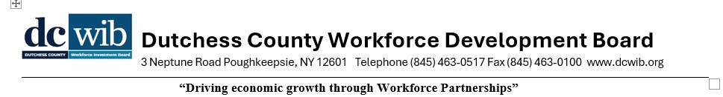NOTICE OF INTENT TO AWARD A SOLE-SOURCE CONTRACT
The Dutchess County Workforce Development Board (DCWIB) intends to award a sole-source contract to Sugolini Consulting Group to serve as the WIOA Center Operator (DCWORKS) for Dutchess County, using Workforce Innovation and Opportunity Act (WIOA) funds, for the period July 1, 2026 – June 30, 2027.
This action follows a competitive procurement process (RFP issued April 9, 2026, re-issued May 1, 2026) that did not result in adequate competition. The sole-source selection is made under 20 CFR 678.610 and 2 CFR 200.320.
Any party objecting to this intended award, or any qualified entity wishing to express interest, must submit written comments to taylor@dcwib.org or DCWIB, Attn: WIOA Operator RFP, 3 Neptune Road, Poughkeepsie, NY 12601, no later than June 30, 2026 at 4:00 PM.
Published 6/19/2026

